

Software Engineering

[UML Diagrams]

**-Submitted by-**

**Name:** G. Bhoomika

**Reg_no:** 211FA04228

**Batch_no**:12

**Section:** C

Project-5:

An Automated Community Portal:

Business in the 21st Century is above all BUSY. Distractions are everywhere. The current crop of “enterprise intranet portals” is often high noise and low value, despite the large capital expenditures it takes to stand them up. Email takes up 30 - 70% of an employee’s time. Chat and Instant Messaging are either in the enterprise or just around the corner. Meanwhile, management is tasked with unforeseen and unfunded leadership and change-agent roles as well as leadership development and succession management. What is needed is a simplifi ed, repeatable process that enhances communications within an enterprise, while allowing management and peers to self-select future leaders and easily recognize high performance team members in a dynamic way. Additionally, the system should function as a general-purpose content management, business intelligence and peer-review application. Glasscode’s goal is to build that system.

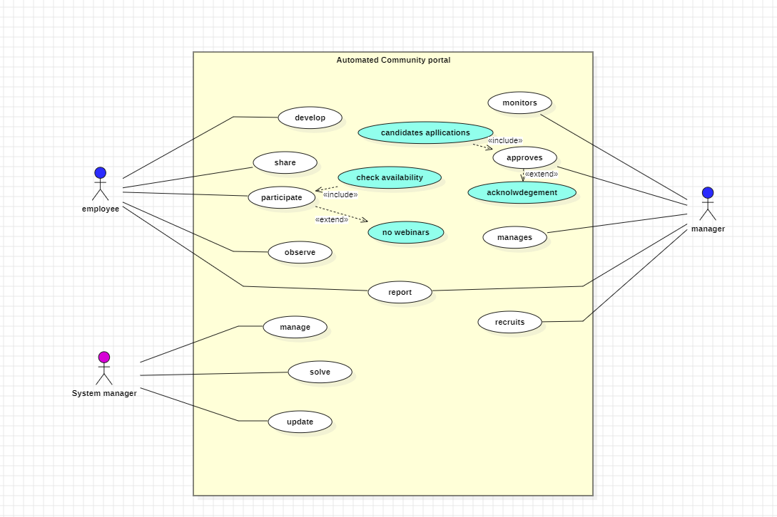1.Use Case Diagram

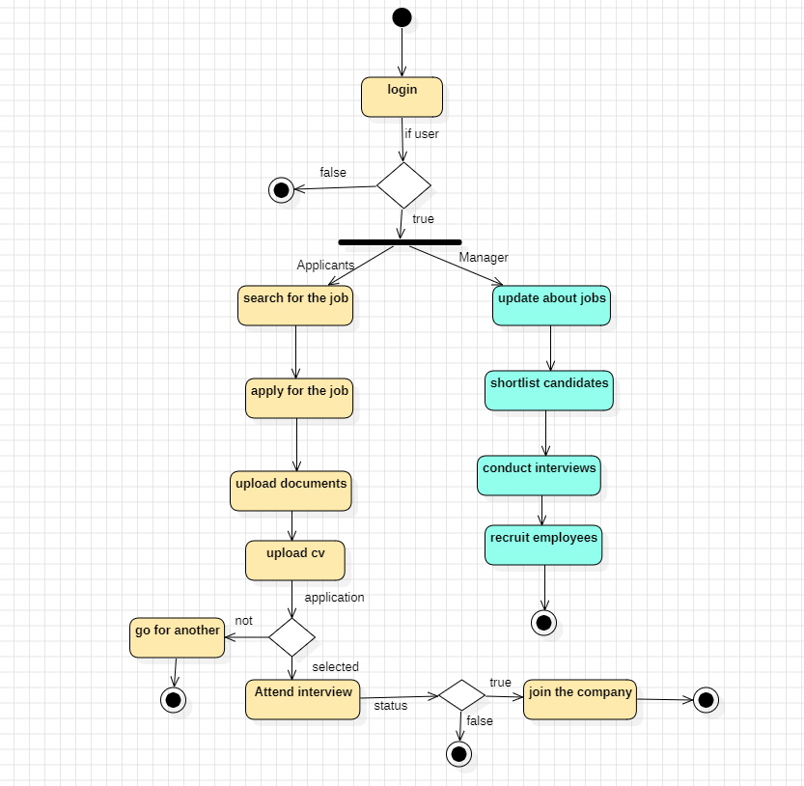2.Activity Diagram

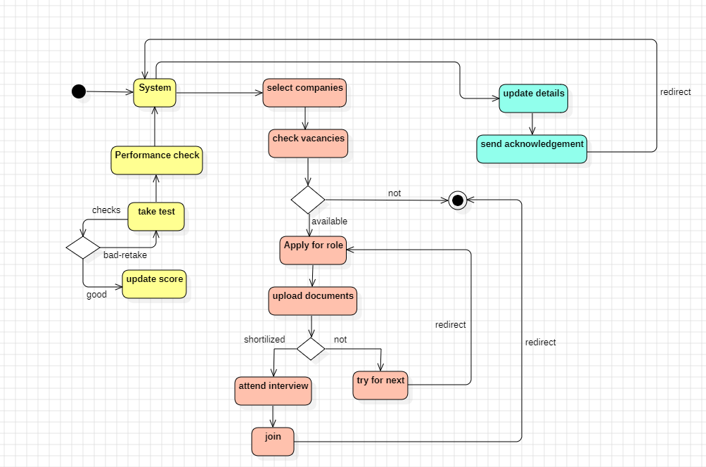3.Statechart Diagram

4.Class Diagram

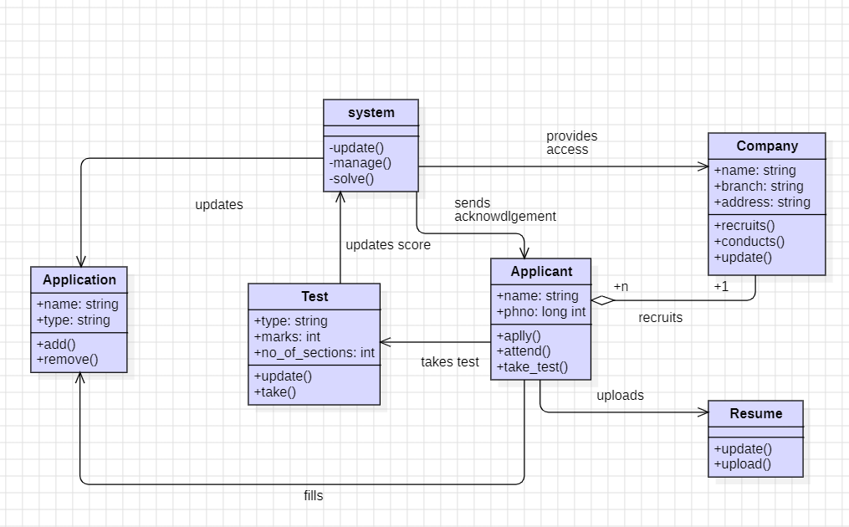

5.Sequence Diagram

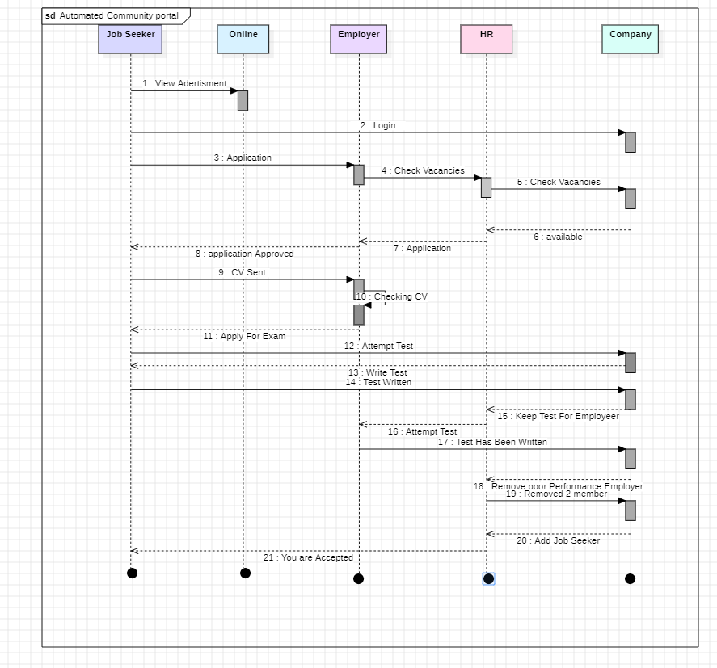

Project-3:

A Simulated Company:

Simulate a small manufacturing company. The resulting application will enable the user to take out a loan, purchase a machine, and over a series of monthly production runs, follow the performance of their company.

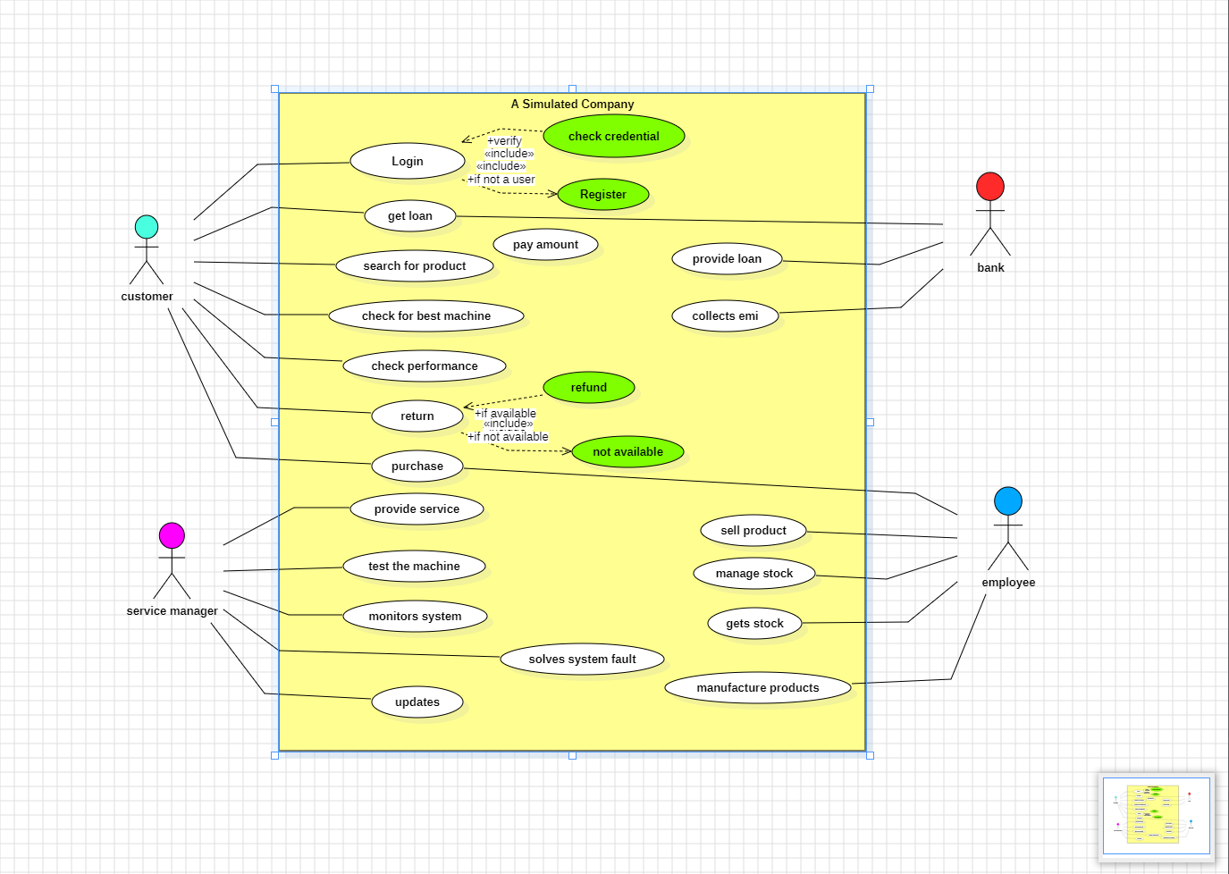1.Usecase Diagram

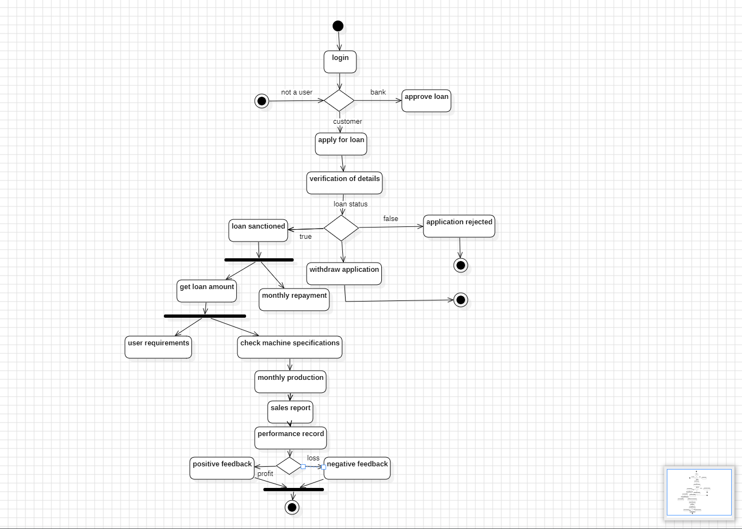2.Activity Diagram

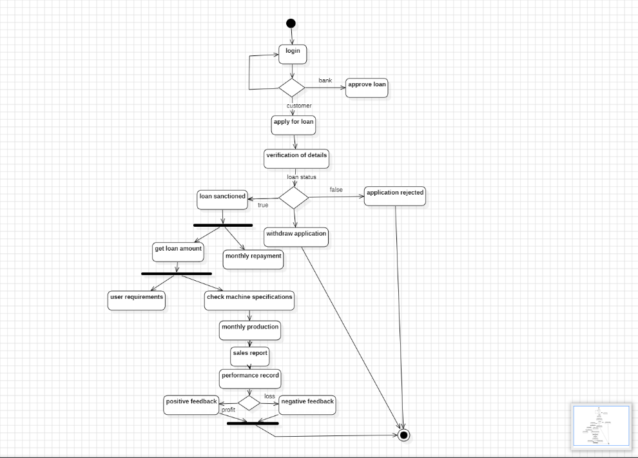3.State chart Diagram

4.Class Diagram

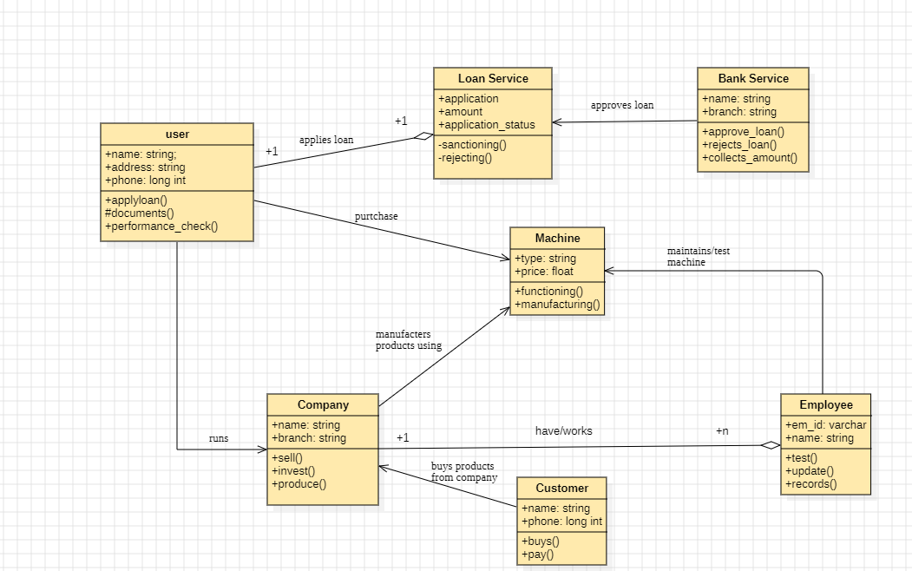

5.Sequence Diagram

